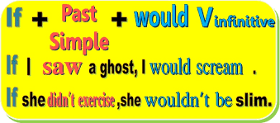
e Second Conditional
We use the second conditional to describe an imaginary situation or event, and its result.
(exercises)
1) Look at the pictures. Use the words below to complete the second conditional sentences.
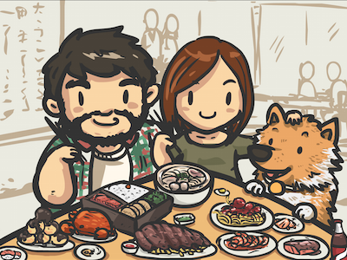



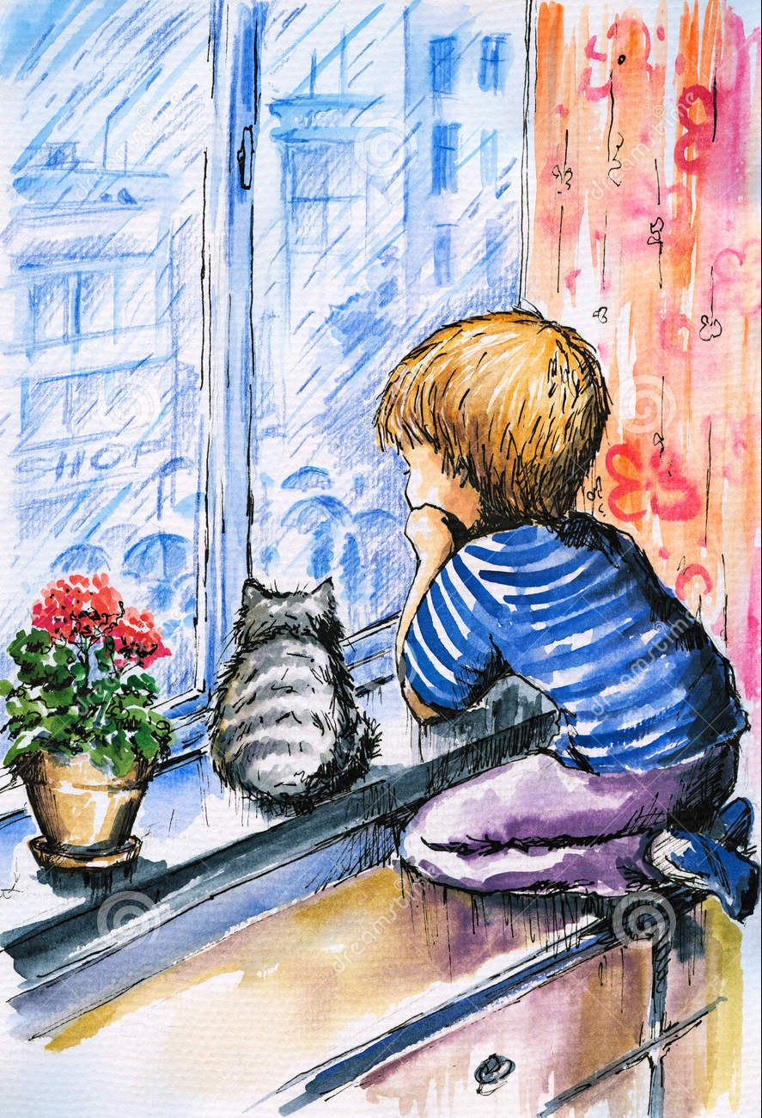
1 2 3 4 5
1. If I were _______________________________________________________________________________
( the Browns / I / let / the dog / sit / at the table )
2. If it was/were __________________________________________________________________________
( sunny / John / stay / at home )
3. Sarah would buy _______________________________________________________________________
( that dress / if / she / be / thinner )
4. Kate could ____________________________________________________________________________
( go / to the cinema / if / Sam / invite / her )
5. If Jake had ____________________________________________________________________________
( more courage / he / go / to the dentist )

2)
2) Complete the second conditional questions with the verbs in brackets.
1. What age ____________ (you / be) if you _________ (can) be any age right now?
2. If you _________ (be) an animal, what animal ___________ (you / be)?
3. Which year _____________ (you / go) to if you ___________ (can) travel backwards in time?
4. If you ______________ (find) a purse full of money in the street, what ______________ (you / do)?
5. How much money _______________ (you /give) to charity if you _________ (win) 1 million pounds?
6. If you ___________ (stop) studying English, ______________your life (change)?
7. _________ (you / cheat) if you __________ (not know) the answer in an exam and nobody was looking?

3) Underline the mistakes in the second conditional sentences and write the correct words on the right.
1. What would you do if you would see a big hairy spider in your bed? ______ saw ______
2. If I spilled orange juice on my English homework, I will be upset. __________________
3. Did you explore a desert island if you were alone on it? __________________
4. What did you do if I forgot your birthday? __________________
5. Would Adam come to the party if we would send him an invitation? __________________
6. If I lived not far from you, we can walk to school together. __________________
7. If you could be anyone in the world, who will you choose to be? __________________
8. Which one item would you rescue if your house is on fire? __________________
9. If you have a special power, what would you be able to do? __________________

